**OUTPUT:**

**PREDICTION**

In the prediction part with the test dataset, the trained model is applied to make predictions on new, unseen data. This involves passing the test dataset through the trained model and obtaining the model's predictions for each sample. The predictions are typically in the form of class labels.

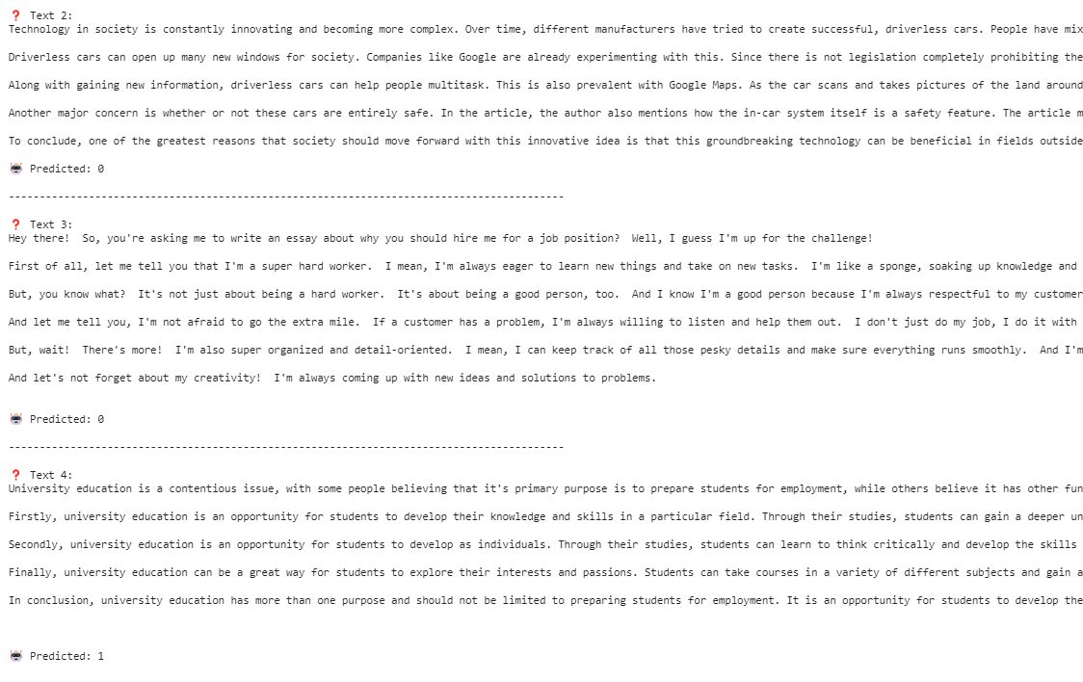

Submission file for the model predictions on the test dataset. It creates a DataFrame to store the predictions alongside the corresponding sample IDs. Subsequently, the formatted predictions are added to the DataFrame. The submission DataFrame is then saved as a CSV file named 'submission.csv'. Finally, the first 2 rows of the submission DataFrame are displayed to confirm the successful creation of the submission file.

